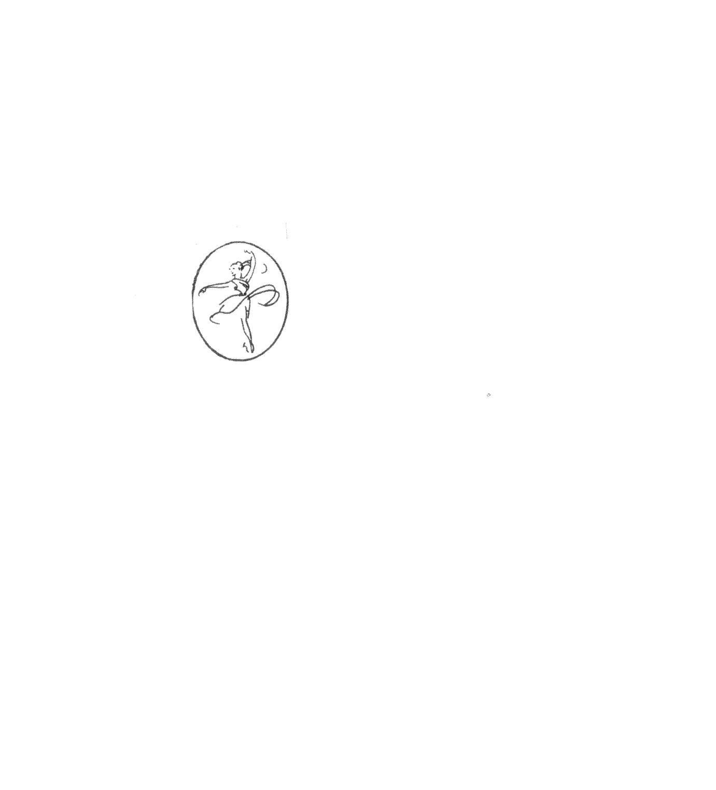**Erinvale School of Dance Ltd.**Pre-Authorized Payment Form

I, NAME authorize the Erinvale School of Dance Ltd. to charge the following payments to the credit card listed below on the dates indicated:

VISA  MC   
Name on Card: FIRST LAST  
Card Number: Click here to enter text. Exp: MONTH/YEAR CVV:CVV

Amount to be charged: $Click here to enter text. Date: Click here to enter text.   
Amount to be charged: $Click here to enter text. Date: Click here to enter text.  
Amount to be charged: $Click here to enter text. Date: Click here to enter text.  
Amount to be charged: $Click here to enter text. Date: Click here to enter text.  
Amount to be charged: $Click here to enter text. Date: Click here to enter text.  
Amount to be charged: $Click here to enter text. Date: Click here to enter text.  
Amount to be charged: $Click here to enter text. Date: Click here to enter text.  
Amount to be charged: $Click here to enter text. Date: Click here to enter text.  
Amount to be charged: $Click here to enter text. Date: Click here to enter text.  
Amount to be charged: $Click here to enter text. Date: Click here to enter text.

A receipt will be emailed upon payment completion.

Name:FIRST LAST   
Student(s): NAME(S)  
Email Address:EMAIL

